Annika Marie

1401 South State Street #1110

Chicago IL 60605

[amarie@colum.edu](mailto:amarie@colum.edu)

**DAVIS, STUART (1892-1964) Word Count: 498**

Stuart Davis was a painter, printmaker, muralist, and arts activist who played a prominent role in the development of American Modernism in the first half of the twentieth century. Visually, he brought the formal and technical experimentation of the European avant-garde to depictions of the modernity of the American metropolis. As a prolific writer and powerful spokesman, Davis was a committed cultural advocate, working to explain and defend modern abstract art, promoting artists’ rights, and arguing for the democratization of culture and art’s formative impact on society. Davis’s early style relates to the Ashcan School, an early twentieth-century brand of realism that combines a direct, spontaneous journalistic naturalism with everyday scenes of urban street life. At sixteen years of age, Davis left his native Philadelphia to move to New York City and study art with Robert Henri, one of the best known Ashcan painters. The turning point for the young Davis was the New York Armory Show of 1913. Through the exhibit Davis was exposed to Fauvism, Expressionism, Cubism, and Dada, and the boldly aggressive plastic elements with the radical approaches to pictorial space left an indelible impression.

However, Davis’s embrace of the formal rigor of European abstraction did not lead him to pure, non-objective painting. Maintaining that form and content were equally important, he argued that European Modernism’s visual fragmentation, instability, and simultaneity provided the visual means by which to express contemporary American urban life: the dizzying spatial disjuncture and cacophonies of industrialization, popular culture, jazz music, skyscrapers, subway trains, televised media, outdoor advertising, and product packaging. In repeatedly turning to common everyday objects for the subject matter of his art—as evidenced in some of his best known series, such as his “Tobacco” and “Eggbeater” series of the 1920s—Davis retained the social engagement and “realism” of Henri and the Ashcan School. During the Great Depression of the 1930s, Davis was active in the Federal Arts Project, both painting a number of public murals under the auspices of the Works Progress Administration and mobilizing artists through the politically leftist organizations of the Artists’ Union (for which he served as the editor of the union’s publication, *Art Front*) and the American Artists’ Congress (serving in 1936 as its first national secretary and in 1938 as national chairman). Through these organizations, Davis was immersed in the decade’s heated debates over art and politics. Importantly, Davis’s dual commitments to a Modernist visual idiom and to local popular subject matter allowed him to cut through the polarization between apolitical formal abstraction and political social realisms. Davis maintained the belief in a progressive, socially-engaged Modernist art practice.

**References and Further Reading**

Christ, J. X. (2008) “Stuart Davis and the Politics of Experience.” *American Art* Vol. 22, No. 2, Summer, 42-63.

David, S. (1991). “An Interview with Stuart Davis.” *Archives of American Art Journal.* Vol. 31, No. 2. 4-13.

Hills, P. (1996). *Stuart Davis.* New York: Harry N. Abrams.

Lane, J. R. (1978) *Stuart Davis: Art and Art Theory*. New York: The Brooklyn Museum.

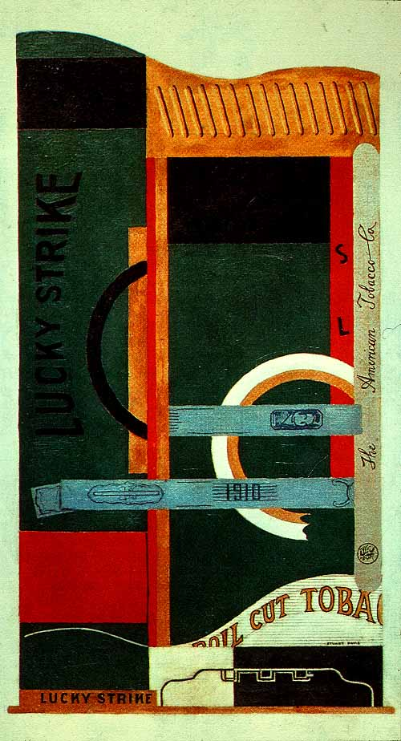

[**Stuart Davis**](http://www.moma.org/collection/artist.php?artist_id=1412) **(American, 1892–1964), *Lucky Strike*** 1921

Medium: Oil on canvas

Dimensions: 33 1/4 x 18" (84.5 x 45.7 cm)

Credit Line:

Gift of The American Tobacco Company, Inc.

MoMA Number:

132.1951

<http://www.moma.org/collection/browse_results.php?criteria=O%3AAD%3AE%3A1412&page_number=4&template_id=1&sort_order=1>